PhD Program in Cancer and Immunology

Application

1. Personal Data
Last Name: First name:
Address: Email:
Telephone:
Date of Birth: Nationality:

2. Procedure
Select if you are a track 2 or track 1 candidate:

Track1 Track2

Track 2:
The track 2 candidate send his/her complete application mentioning the position he/she wish to apply for.
Track 1 :
The track 1 candidate have already identified a match with a laboratory. The laboratory will host the candidate for a PhD.
The track 1 will have to pass the official selection to the PhD program in cancer and immunology as the track 2

3. Choice of laboratories and research interests
Please indicate the name of the thesis directors you have chosen from the list provided on our website: www.unil.ch/cancer-immunology/page55876.html If possible, list up to 5 choices. Note that not all laboratories have open positions and that you may be invited to interview in labs with similar and related interests.

1)
2)
3)
4)
5)

Please check the boxes on the next page that best match your research interests

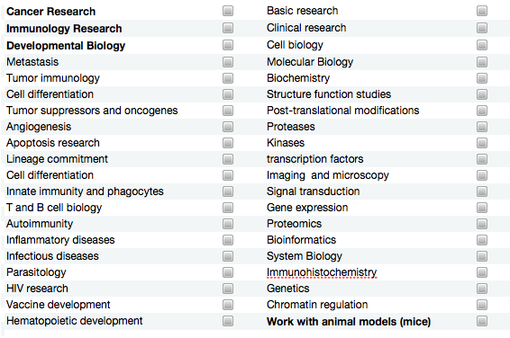
Other fields or interest:
1) ………………………………………..………………
2) …………………………………………………………
3) …………………………………………………………

4. Academic information
Please, list all universities where you have studied since high school, starting from the most recent one. Indicate your grades as relative value (ex 15/20 or 4/6). In the two last columns indicate the maximum (best) score possible for each exam at the institution delivering the degree and indicate the minimal score possible in the last column.

Name and city of the University | From | To | Major field of study | Academic scores for  your degrees, | Max  Score  Possible | Min  Score  Possible

5. Referees
Three references are required from people acquainted with your studies and your work. You will find a form on our website to be sent to them (named “reference form”).
Referee 1:

Last Name: First name:
Address:
Email:
Telephone:

Referee 2:

Last Name: First name:
Address:
Email: Telephone:

Referee 3:

Last Name: First name:
Address: Email:
Telephone:

6. Previous research experience
Employer:
Address of Employer:
Position held:
Description of your work, indicating personal responsibilities:

7. Publications and awards
Publication list:

Award(s):

8. Objectives
Please list here your main subjects of scientific interest (present and future) and potential hosting laboratories. Include as far as you can your particular interests, be they experimental, theoretical or issue-oriented, and show how your background and our programme support these interests (1 page max.).

1)
2)
3)
4)
5)

9. Language Proficiency

Mother tongue:
Other language(s) of which you have a working knowledge:
Do you use English in your work? Yes No Sometimes

10. Signature

(place) (date):31/5/2020

(signature)

The completed application form should be accompanied with

-A List Bachelor and Master diplomas and courses with corresponding grades, with relative scale of values (indicating max and min scores that are used in the institution delivering the degree)
Copy of the diplomas and official grades will be asked if you are selected for interviews.

- Curriculum Vitae

- 3 Referees letters (sent by the applicant or the referent)

and returned back via email or mail to:

PhD Program in Cancer and Immunology
Administration Office
Department of Immunobiology
Chemin des Boveresses 155
CH-1066 Epalinges
Switzerland

Email : cancerimmunology@unil.ch

