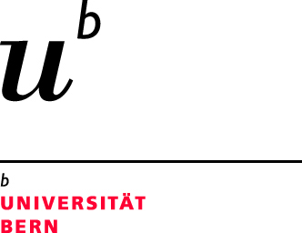

Secrecy and Surveillance in Medieval and Modern England

Sixth International Conferences of the
Swiss Association of Medieval and Early Modern English Studies

13–14 September 2018
University of Bern

Registration Form

Please fill in this form and send it to samuel.roeoesli@ens.unibe.ch by 1 August 2018.

1/ Contact information

Name:
Affiliation:
Address:
Phone:
E-Mail:

2/ Registration fee

The registration fee is waived for those who will have paid the SAMEMES membership fee for at least two consecutive years at the moment of registration.

For non-members, the following fees apply:
students 40,- CHF
all other participants 80,- CHF

The contribution to the conference dinner covers a three-course meal (including water and one glass of wine).

Please do not forget to give your name along with the payment reference.
Participants are requested to ensure that they cover all possible bank transfer fees.

I hereby confirm that I have paid the conference fee of 40,- / 80,- CHF into the account specified below.

I hereby confirm that I have paid the contribution to the conference dinner into the account specified below (please select menu option):

vegetarian option (55,- CHF)

meat option (60,- CHF)

Bank account details:

Beneficiary: Universität Bern, 3012 Bern
Account: 30-6618-3
IBAN: CH 90 0900 0000 3000 6618 3
Swift: POFICHBE
Clearing: 09000
Payment reference: 1535, Kredit-Nr. 36-827, (your name)

