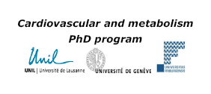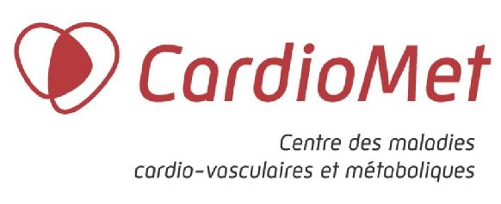

CardioMet Mini-symposium

“Computational Biology in Metabolism
and Cardiovascular Research”

Friday September 19, 2008
CHUV - Lausanne
Rue du Bugnon 46, 1011 Lausanne

Organizers : Prof. Peter Vollenweider and Dr. Fabienne Maurer
Enquiries : Mrs Marina Leuba

REGISTRATION FORM

Name
Surname
Address
Phone
Email address
I will attend to the symposium – Morning (yes/no)
I will attend to the Discussion – Afternoon (yes/no)
I will attend to the lunch (yes/no)
I will attend to the “Wine and Cheese” (yes/no)

Thank you to send this registration form to the above email address :

Marina.Leuba@chuv.ch

Deadline : Monday August 25, 2008

