Master in Earth Sciences

by

LAST NAME First Name
(of the candidate)

Title

Area to be adjusted to your needs

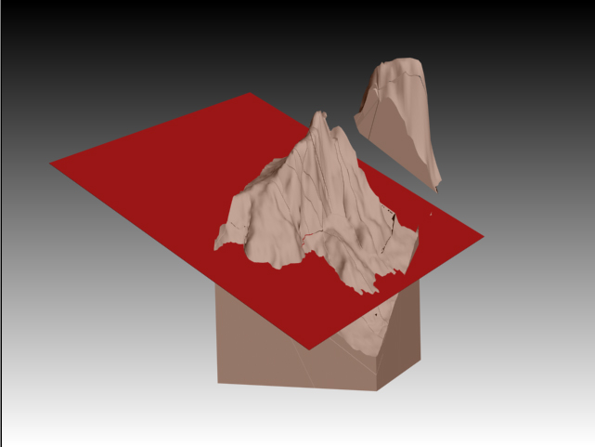

Your illustration
&
size to be adjusted to your needs

Under the supervision of:
Title, LAST NAME-S First name-s
(Ex. Dr SANTA Claus)
ATTENTION: Indicate the name of the co-supervisor if any

Signature of the supervisor-s Université de Genève
Leave space for the signature-s Date of the document (d/m/y)
ATTENTION - This page must be placed after the title page (i.e. page 2 single print)

STATEMENT

I certify that all statements in this text, that are not the result of my personal reflection, are attributed to the appropriate literature and that any passage copied from another source is placed in quotes.

DISCLAIMER
The information contained in this report is part of an academic exercise and represents the work of the author and neither the ELSTE nor the University of Geneva. The author and the ELSTE disclaim any liability in connection with the use of this information.

COPYRIGHT
Quotations from this memoire are permitted only if they serve as a comment, reference or demonstration to the user. The quote must imperatively mention the source and the author's name. The Swiss federal law on copyright and Neighbouring Rights (LDA) are applicable.

Document to be completed for the final submission of the master thesis

ELSTE master's studies in Earth Sciences are legally considered as examination papers and are therefore confidential.

The author and his or her supervisor(s) must therefore agree to the method of dissemination, for scientific research purposes, without commercial purpose, of the thesis work, by ticking the appropriate options below:

- Distribution is possible in both paper and electronic formats by the library.
- The work cannot be taken out of the library, either in paper or in electronic form.
- The work is subject to an embargo until the date of:
d/m/y……………………………
- The embargo may be lifted before the date indicated, with the agreement of the Thesis supervisor(s):
  - Yes
  - No

Author:

Last Name, First Name: ……………………………………

Date, Place: ………………………………………………....

Signature: ……………………………………………...........

Supervisor-s:

Last Name, First Name: ……………………………………

Date, Place: …………………………………………………

Signature: ……………………………………………………

RESUME

Taille de la zone à moduler selon votre besoin
(1 à 3 pages)

Mots-clés : indiquer 5 mots clés

ABSTRACT

Size of the area to be modulated according to your needs

(1 to 3 pages)

Keywords: indicate 5 key words

